Youtube Summariser Agent 🎬
5 Key Takeaways
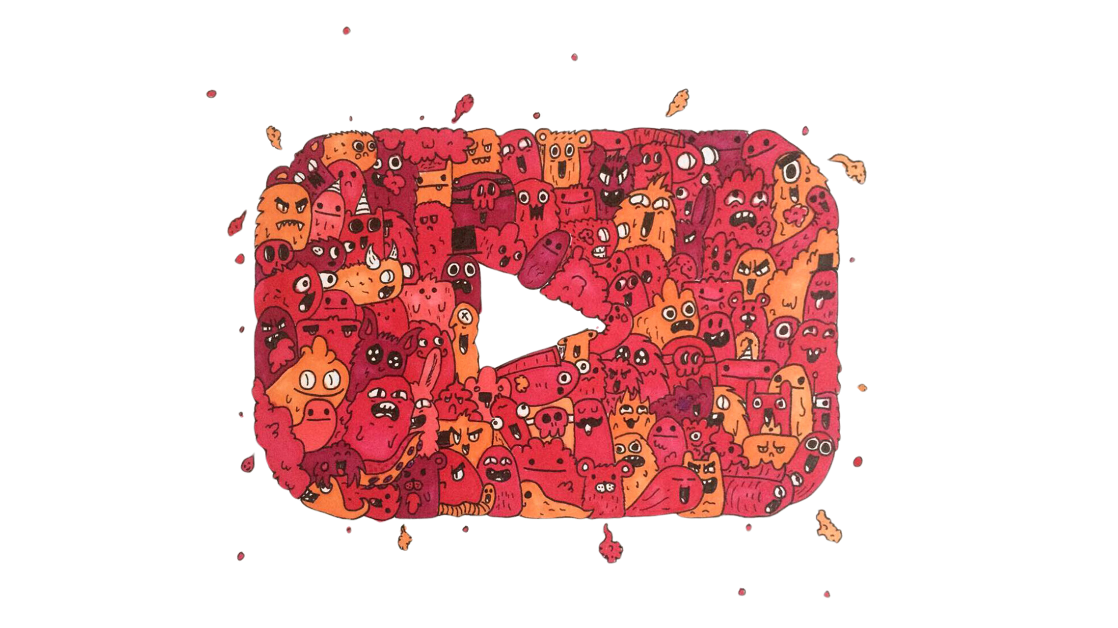
Prompt:
You will be provided with the full transcript text for a video. Using only this information, please generate the following outputs using Google Docs-compatible formatting:

Key Takeaways:
Provide a bulleted list with the 5 most important insights, conclusions, or pieces of actionable advice from the video
- Use concise bullet points that focus on the central ideas
- Include one relevant emoji at the beginning of each bullet point

Apply the following formatting to the list:
- Use "🔑 Key Takeaways" as the heading, with bold text and an emoji
- Prefix each bullet point with a hyphen followed by a space "- "
- Add a blank line between the heading and the first bullet point

Summary:
- Write a comprehensive summary of the video in approximately 1000 words
- Expand on the key takeaways, and include relevant supporting details and examples
- Organize the summary into logical paragraphs with clear transitions
- Aim to cover all main ideas while remaining concise
- If the video is less than 10 minutes long, adjust the word count of the summary to avoid unnecessary padding (target ~500 words for 5 minute videos)

If the video is over 30 minutes long, focus the summary on only the most critical main points that fit within 1000 words. Mention that you are excerpting highlights only due to the length.
Use the following formatting for the summary:

- Use "📝 Summary" as the heading, with bold text and an emoji
- Separate paragraphs with a blank line
- Use italic text to emphasize words or phrases
- Add a blank line between the heading and the first line of the transcript

Please add two blank lines between each section (Key Takeaways, Summary, and Transcript) to improve readability.

Do not mention that this is a summary of a YouTube video in the outputs. Simply present the takeaways, summary, and transcript directly without an introduction, using the specified formatting that is compatible with Google Docs.

